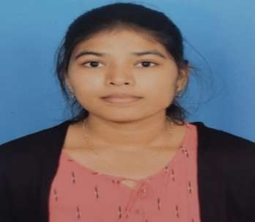
Indu Nadella
 +91 6304626984
indu.nadella1122@gmail.com
 Indu Nadella
 indunadella
Address: Kovur, Nellore district (AP)- 523105

CAREER OBJECTIVE
Seeking a challenging position in a respected organization to apply technical and management skills for company growth. Dedicated to staying current with emerging trends and leveraging knowledge for strategic advancement.

EDUCATION
- Prakasam Engineering College, JNTUK 2021-Present
B.Tech, Computer Science and Engineering CGPA: 8.63
- Narayana Junior College 2019-2021
Board of Intermediate Education, Andhra Pradesh Percentage: 96
- Narayana English Medium School 2018-2019
Board of Secondary Education, Andhra Pradesh GPA: 10.0

INTERNSHIP EXPERIENCE

Brain O Vision Pvt. Ltd
Summer Intern- Web Development
-Developed and optimized web pages using HTML, CSS and JavaScript, enhancing user experience across mobile and desktop devices. And responsible for programming design, teamwork, database and security.

ExcelR Edtech Pvt. Ltd
Intern- Java Programming
-Gained hands-on experience in software development using the Java Programming language, and developed proficiency
in java, including concepts of OOPS principles, Exception Handling and Multithreading.

PROJECTS

Bank Record Storage System Through Blockchain
Developed a secure and decentralized banking record storage system leveraging blockchain technology to ensure transparency, immutability, and efficiency in financial data management. Designed to prevent fraud, enhance security, and streamline across financial records while maintaining regulatory compliance.
  - Tools & Technologies used: Blockchain, Smart Contracts, Cryptographic Hashing (SHA-256), MYSQL - Used with WAMPServer.

Image Caption Generator
Implemented an image caption generator using the Xception model, merging computer vision and natural language processing.
  - Tools & technologies used: Colab, VS code, Tensor Flow, Keras, NumPy, Pandas, Matplotlib, Python
  - Trained the model on a sizable dataset to precisely describe images with captions, enhancing its ability to generate accurate and contextually relevant captions.

SKILL SET AND INTERESTS
Technical Skills: Java, SQL, HTML, CSS, Microsoft Excel.
Soft Skills: Teamwork, Communication, Quick Learner, Problem Solving skill, Time Management.
Hobbies: Cooking, Drawing, Listening to music.
Languages known: English, Telugu

ACHIEVEMNETS AND CERTIFICATIONS
- Certifies in Python for Data Science, AI & Development- Coursera
- Certifies in HTML and CSS- Brain O Vision
- Certifies in Java Programming- ExcelR
- Solved over 100 problems on CodeChef and HackerRank.

